**QUESTIONS AND DATA QUERY OUTPUT**

**TABLE SNIPS OF DATA OUTPUT FROM THE SQL QUERIES IN THIS PROJECT ARE SHOWN BELOW:**

Q1;

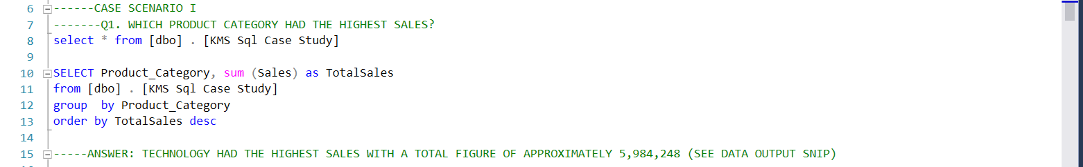

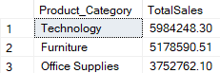

Q2i;

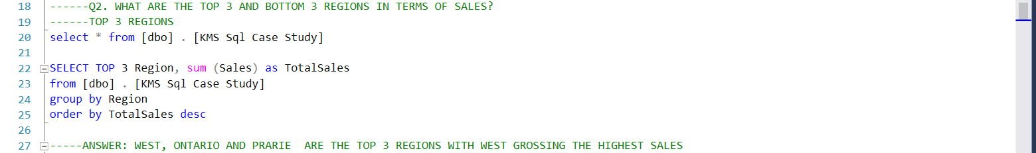

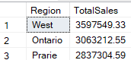

Q2ii;

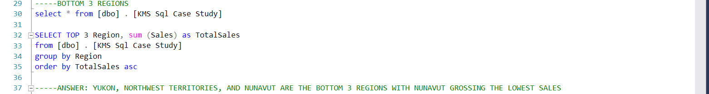

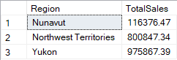

Q3;

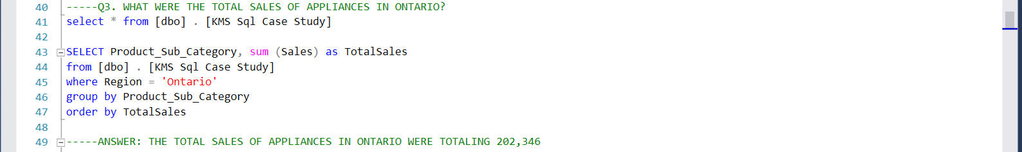

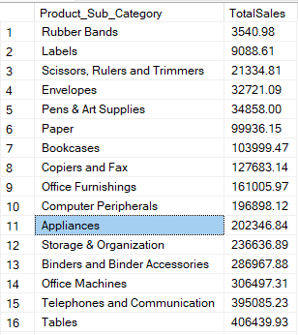



Q4;

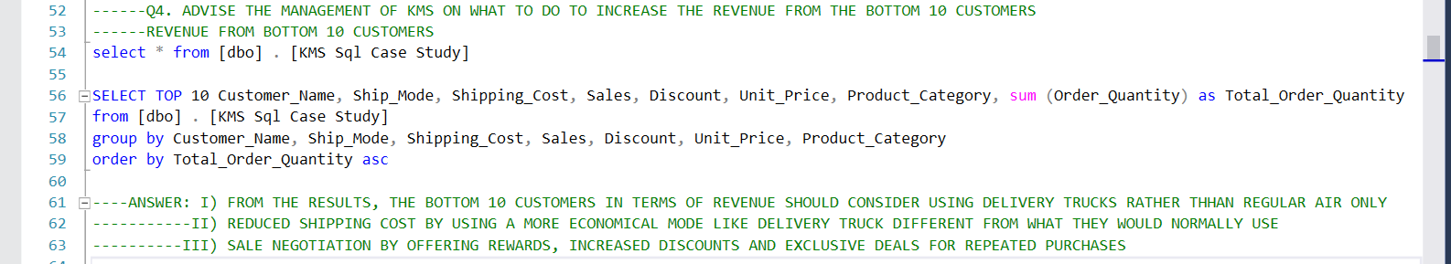

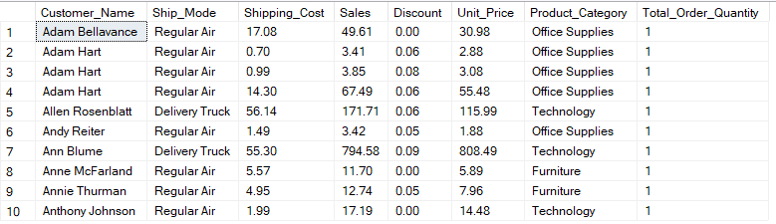

Q5;

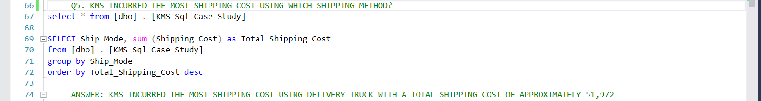

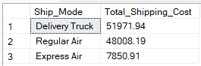

Q6;

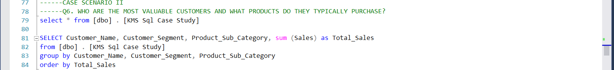

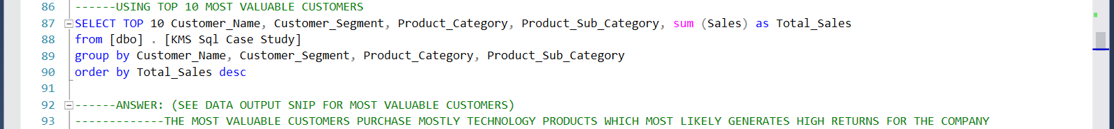

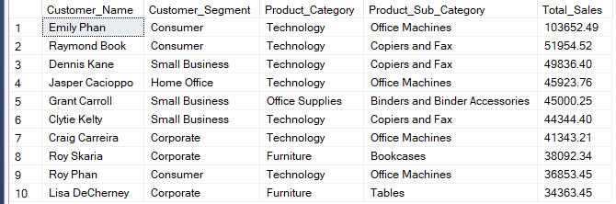

Q7;

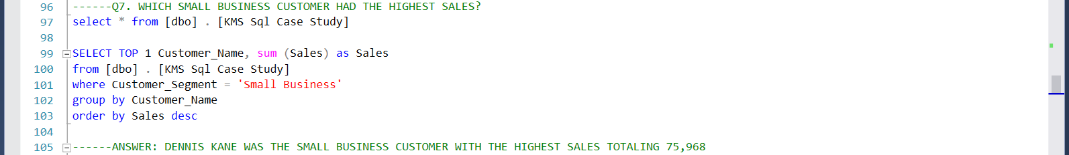



Q8;

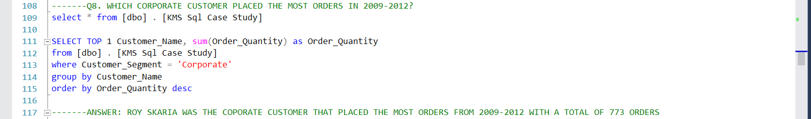



Q9;

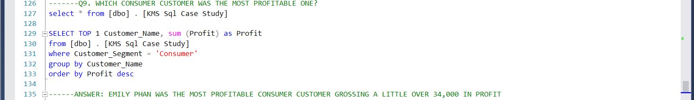



Q10;

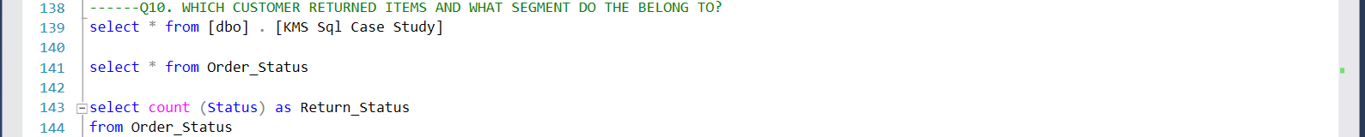

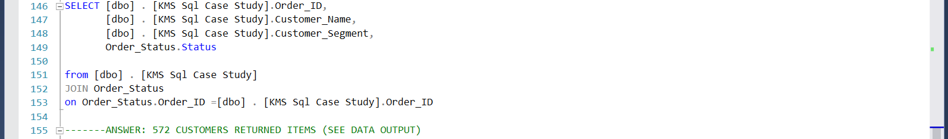



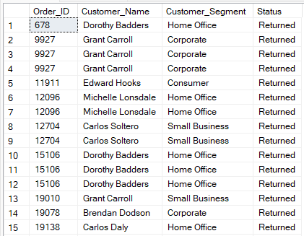

Q11;

